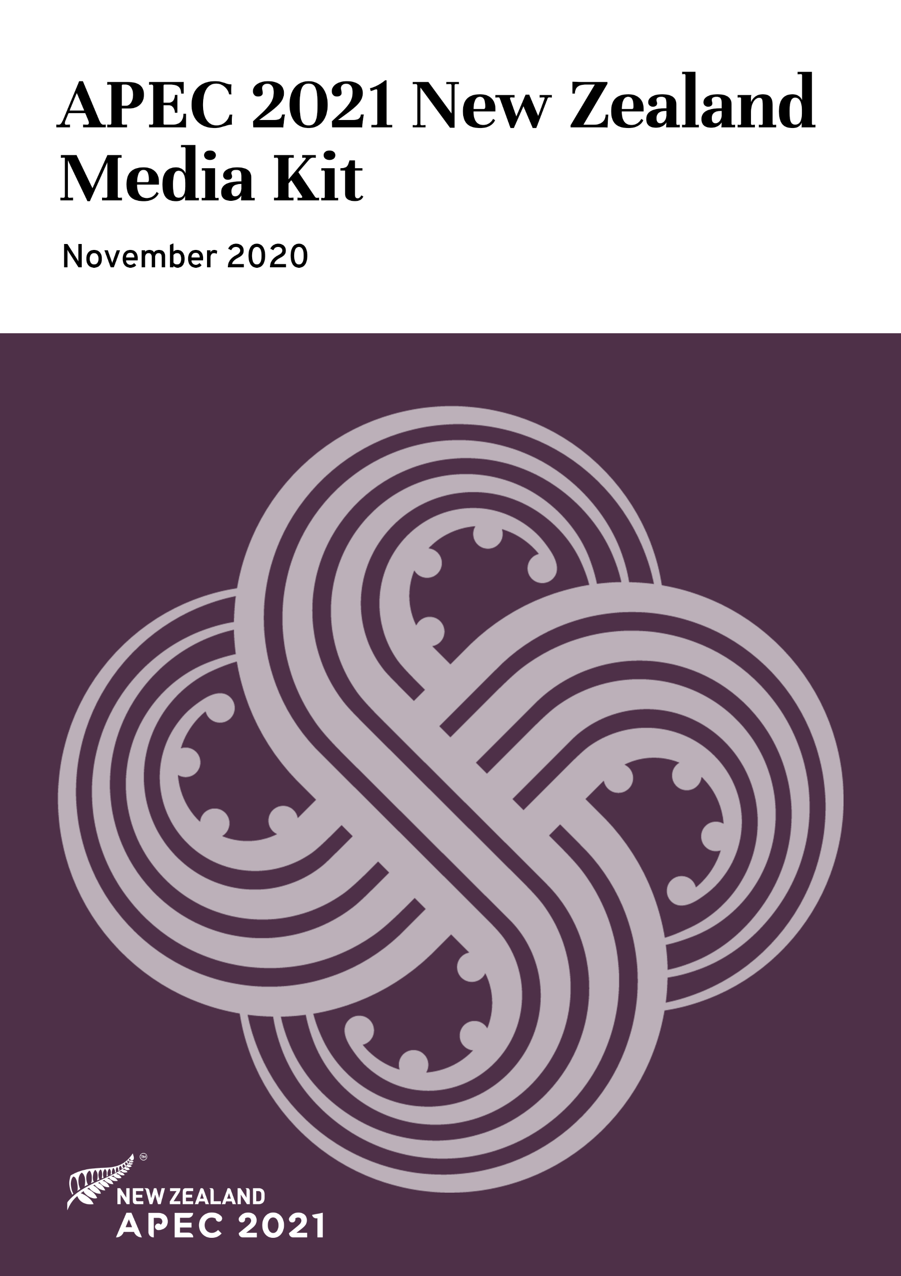

Haere mai / Welcome

For the first time ever, New Zealand will host the entire APEC year virtually in 2021 and we are committed to providing media with access to everything they need to cover APEC 2021 remotely.

As incoming Chair, New Zealand will build on Malaysia’s work and ensure APEC is focused on making a difference for everyone in the Asia Pacific region. This will include continuing APEC’s critical work in leading a collaborative regional response to the economic impacts of COVID-19 and the development of an action agenda to achieve APEC’s renewed vision.

To launch New Zealand’s host year, the official APEC 2021 handover video was played at the closing meetings of Malaysia’s host year to provide delegates with a taste of what to expect at APEC 2021. This video, along with other image and video files and a digital version of this media kit, are available to view on the APEC 2021 website (under the Media Kits tab on the Media Resources page) – apec2021nz.org.

APEC 2021: A guide for media

Contacting the media team
Media registration enquiries: APEC2021Support@mfat.govt.nz
All other media enquiries, including interview requests: APEC2021media@mfat.govt.nz

Official APEC 2021 channels
Website: apec2021nz.org
Social media: Follow along #APEC2021
- Twitter
- Facebook
- YouTube
- LinkedIn

Sign up for media updates
Sign up for APEC 2021 media updates by emailing APEC2021media@mfat.govt.nz, using the subject line ‘Media updates’. We will notify you when registration opens for each meeting cluster and share media content and story ideas throughout the year.
Media registration
Media will not be required to register for the Informal Senior Officials’ Meeting (ISOM), which takes place 9-11 December, 2020. You will, however, be given access to the opening of ISOM, either by live-stream or a video recording of the event. More details will be published via an ISOM media advisory at the end of November.
From Senior Officials’ Meeting 1 (SOM 1) onwards, if you are not part of an APEC media delegation, and wish to register as a media delegate, you will need to apply by emailing APEC2021Support@mfat.govt.nz. We will need the following information to consider your application:
- First name and surname
- Email address
- Media organisation
- Letter confirming employment by your media organisation
Once your application is approved, you will be able to access the APEC 2021 Registration Portal to complete your registration. The portal will provide access to APEC 2021 virtual media events, including media conferences. The official registration process will typically open four weeks prior to each group of meetings. The APEC 2021 meeting calendar can be viewed at apec2021nz.org.
If you need assistance with the registration process at any stage, please contact APEC2021Support@mfat.govt.nz.
Virtual media conferences
Interactive virtual media conferences will be held after key APEC 2021 meetings, providing media with access to Ministers and Economic Leaders. Media conference details will be shared via media advisories before each meeting cluster. The first virtual media conference is planned for the opening of SOM 1 in February 2021.

Accessing media materials
apec2021nz.org: The media resources section of the website houses APEC 2021 media releases, videos, images, New Zealand business case studies and media kits, which will be created for each meeting cluster. High resolution video and image files displayed on the website can be requested by emailing APEC2021media@mfat.govt.nz

Media content platform: From SOM 1, media will have access to a media content platform that will allow the direct download of high resolution images and video files. Video footage and images will be captured at key events, including media conferences, and made available to media as edited packages or raw footage. Details for accessing the media content platform will be provided in the SOM 1 media advisory.

What is APEC?

APEC was established in 1989, and in 1994 adopted the Bogor Goals – a vision of free and open trade and investment in the Asia-Pacific by 2020. APEC's 21 members aim to create greater prosperity for the people of the region by promoting balanced, inclusive, sustainable, innovative and secure growth and by accelerating regional economic integration.
APEC brings together officials, Ministers and Leaders from around the Asia-Pacific region for a series of meetings and events each year. The first APEC meeting hosted by New Zealand will be the Informal Senior Officials Meeting (ISOM) between 9 and 11 December 2020, followed by a first formal gathering of officials in February 2021.

A virtual APEC 2021

New Zealand’s decision to host APEC virtually followed months of global disruption and uncertainty from the COVID-19 pandemic. This decision ensures APEC’s work to support regional cooperation and progress can continue, regardless of the changing COVID-19 situation around the world.

APEC 2021 – in numbers
- 21 APEC economies.
- 12 months of meetings.
- More than 40 APEC groups and committees holding meetings on our virtual meeting platform; each group will hold multiple meetings throughout the year.
- Thousands of delegates expected to participate.
- 11 timezones, at times spanning a 17-hour time difference.

Logistics and security
Managing 12 months of virtual meetings is a first for New Zealand, but creative and technological leaders from across the country will us to help create a virtual system that is as intuitive, engaging and productive as possible.
There will be a range of meeting formats, including virtual round tables, media briefings, break-out sessions and a symposium. An event management system will support registration and provide delegates with access to meetings and meeting documents.
Underpinning the technology is a strong focus on security. APEC New Zealand is working with experts in the area to ensure the entire year is as secure as possible.

Being a good virtual host
Although APEC members will be meeting digitally, delegates will experience New Zealand innovation and manaakitanga (hospitality). We are committed to creating a smooth digital process for delegates, and to giving them a chance to learn more about New Zealand culture through our style of hosting, and design elements incorporated throughout the year.

APEC 2021 themes

Join together
There has never been a more important time to join together. As we plan for recovery from Covid-19, it is APEC, the most dynamic region in the world economy, that will help us all rebuild and recover.

Work together
Like never before, the scale of the challenges the world faces today requires us all to work together in the interests of the greater good. We will create an environment where differing points of view can be expressed, debate can take place, where fairness prevails and connections can be made.

Grow together
The way we respond as a region to today’s challenges will be felt for generations to come. APEC 2021 New Zealand will be the start of reigniting growth and setting a plan for a long-lasting recovery for the entire region.

Haumi ē, hui ē, taiki ē
Traditionally, building a waka (canoe) involved entire Māori communities working in harmony toward a common goal. These waka enabled Māori to traverse vast expanses of ocean. Throughout APEC 2021 we will reference the teamwork and collaboration required in building waka. The words haumi ē, hui ē, taiki ē describe the collaborative effort required to reach a common goal.

Join, Work, Grow. Together.
Haumi ē, Hui ē, Tāiki ē.

APEC 2021: New Zealand leaders

Prime Minister – Rt Hon Jacinda Ardern
New Zealand Prime Minister Jacinda Ardern will chair the APEC Economic Leaders’ Meeting in 2021. In her role as Prime Minister, she has attended APEC Leaders’ Meetings in Viet Nam (2017), Papua New Guinea (2018) and participated virtually in Malaysia’s Leaders’ Meeting in 2020.

Ms Ardern, who was recently elected to her second term as Prime Minister, first entered New Zealand’s Parliament in 2008. Over her 12 years as a representative she has been a strong advocate for children, women, and the right of every New Zealander to have meaningful work.

As well as Prime Minister, she holds the roles of Minister for National Security and Intelligence, and Minister for Child Poverty Reduction, an issue particularly close to her heart. She is also the Minister Responsible for Ministerial Services and Associate Minister for Arts, Culture and Heritage.

Minister for Foreign Affairs – Hon Nanaia Mahuta
As New Zealand Foreign Affairs Minister, Nanaia Mahuta will chair the APEC Ministerial Meeting in November 2021. In the 2020 Labour Government, Ms Mahuta became the first woman to hold the New Zealand Foreign Affairs portfolio. She is also Minister of Local Government, and Associate Minister for Māori Development.

Ms Mahuta is a tribal member of Waikato-Tainui, Ngāti Maniapoto and Ngāti Manu. During the Minister’s 20-plus years in Parliament, she has supported policies and initiatives that built the capacity of communities, especially social service organisations, greater investment in education, employment and training opportunities for young people. Her parliamentary experience has enabled her to contribute to the collective aspirations of Māori and all New Zealanders.

Minister for Trade and Export Growth – Hon Damien O’Connor
As New Zealand Trade and Export Growth Minister, Damien O’Connor will chair the APEC Ministers Responsible for Trade Meeting in 2021. Mr O’Connor’s background in farming and adventure tourism drives his view that well-paid, sustainable jobs and industry growth are needed to improve everyone’s future. He is a passionate advocate for rural communities and for a thriving agricultural sector.

Mr O’Connor was first elected to Parliament in 1993 and in the 2020 Labour Government, was appointed Minister for Trade and Export Growth, Minister of Agriculture, Minister for Biosecurity, Minister for Land Information, and Minister for Rural Communities.

Deputy Secretary, APEC New Zealand – Andrea Smith
As Deputy Secretary of APEC New Zealand in the Ministry of Foreign Affairs and Trade, Andrea Smith is responsible for leading the all-of-government team that will deliver New Zealand’s APEC host year in 2021.

Prior to this role, she was Deputy Secretary for the Ministry’s Americas and Asia Group for five years, leading the management of New Zealand’s relationships with all the countries of Asia and North and South America. Ms Smith served as Ambassador to Turkey, Israel and Jordan and as Representative to the Palestinian Authority (2009 to 2011). She was also Director of the Ministry’s Pacific Division (2011-12) and was seconded to the Department of Prime Minister and Cabinet as a Foreign Policy Advisor to then Prime Minister Helen Clark (2006-08).

SOM Chair 2021 - Vangelis Vitalis
Vangelis Vitalis is the APEC 2021 Senior Officials’ Meeting (SOM) Chair for New Zealand’s host year. The SOM Chair is appointed by the host economy to facilitate the APEC policy agenda and coordinate the work of the Senior Officials. As hosts in 2021, New Zealand will chair the APEC Senior Officials Meetings.

Mr Vitalis is also the Ministry of Foreign Affairs’ Deputy Secretary, Trade and Economic. He is an experienced negotiator, currently holding the role of Chief Negotiator for the Free Trade Agreement with the European Union. Previously, he was the Chief Negotiator who concluded the Comprehensive and Progressive Agreement for Trans-Pacific Partnership and, before that, in 2007-9 led the conclusion of the ASEAN-Australia-New Zealand Free Trade Agreement (AANZFTA) and the Malaysia-New Zealand Free Trade Agreement (MNZFTA).

Prior to joining the Ministry, Mr Vitalis was New Zealand’s Permanent Representative to the World Trade Organisation (WTO) in Geneva. He has also been the Ambassador to the European Union and NATO in Brussels and had postings to Canberra and Moscow.

Supporting media materials

Videos:
- New Zealand’s official APEC 2021 handover video, played at the closing meetings of Malaysia’s host year to provide delegates with a taste of what to expect at APEC 2021. Features comments by Prime Minister Jacinda Ardern. View video.
- Still images from the official handover video available upon request.

- Video of SOM Chair Vangelis Vitalis and APEC New Zealand Deputy Secretary Andrea Smith discussing the importance of APEC at this time and New Zealand’s approach to hosting APEC in 2021. View video.

- Video of Prime Minister Jacinda Ardern in conversation with Microsoft CEO Brad Smith at Malaysia’s CEO Dialogues. View video.

Images:

- Behind-the-scenes images of Prime Minister Jacinda Ardern’s participation in Malaysia’s CEO Dialogues. View images.

- High resolution images of APEC 2021 New Zealand leaders available upon request.

Documents:
- Prime Minister’s media releases:
> New Zealand ready to host APEC virtually
> Prime Minister Jacinda Ardern to attend APEC Leaders’ Summit

- APEC 2021 in one page, a one-page overview of the importance of APEC and New Zealand’s host year. Download PDF

