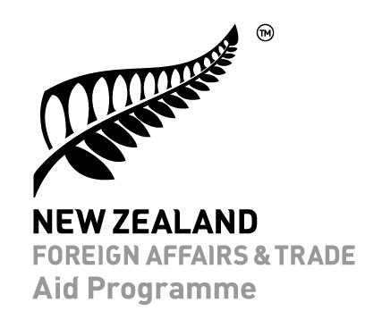
Incident Notification Form

Use this form to report alleged sexual exploitation, abuse or harassment (SEAH) in the New Zealand Aid Programme. MFAT’s policy is that all incidents must be reported. MFAT’s Preventing Sexual Exploitation, Abuse or Harassment Policy is available online here.

Please note: In an emergency, or if someone is in imminent danger, please call 111 (in New Zealand) or visit your local law enforcement office or another support service if safe to do so.

- Please fill in your details, the declaration, and as much of the form as you can.
- Please fill in this form and email it to safeguarding@mfat.govt.nz.
- MFAT collects, uses and discloses this information in accordance with our obligations under the Privacy Act 1993 and our Privacy Policy.
- We care about the safety of victims/survivors. You do not have to provide the name of the victim/survivor or the alleged perpetrator in this form. Please only provide personal details of victims/survivors (such as name, address, race, gender and health) if you have their permission to do so.
- MFAT will use the information to ensure the incident is investigated appropriately.
- We may call you if we need further information.

Contact details and declaration of person completing form

Name

Email address
Phone | Please include the International Country code
Date
Signature

Declaration
By completing and submitting this form, I declare that:
- All of the information I have supplied is true and correct.
- I have read, understood and agree to the collection and use by MFAT of the information contained in this incident notification form.
- Any survivors, victims or whistleblowers mentioned in this form have given me their consent to use this information.

NB: If you do not consent or have concerns about how we will use disclose or share this information, please email MFAT as soon as possible at safeguarding@mfat.govt.nz

Notification Details

Programme/Activity details
Please provide some general information about the Aid Programme activity/ies.

Has this incident occurred on a New Zealand Aid Programme Activity? | ☐ Yes ☐ No
What is the Activity name and reference number? | Activity Name:  Activity Number:
Where is the Activity located? | Village/town/city:
 | Region:
 | Country:
Who are the delivery partners and subcontractors involved in the activity? | Orgnaisation name:  Downstream partners:

Type of incident
Please tell us what kind of incident you are reporting.

☐sexual exploitation | ☐sexual abuse
☐sexual harassment | ☐policy non-compliance

Incident details
Please give us some more information about the alleged incident.
Please provide as much detail as you can.
However, please only provide personal details of victims/survivors (such as name, address, race, gender and health) if you have their permission to do so.

Where did the incident happen? | Village/town/city
 | Region
 | Country
When did it happen? | Date: dd/mm/yyyy
When did your organisation receive an incident report? | Date: dd/mm/yyyy
Please describe details of the alleged incident. | What happened?
Actions taken

Is the victim/survivor being protected from further harm?
Is there a potential risk to other people?
Is the victim/survivor a recipient or delivery partner?
If yes please provide details

Has the victim/survivor been referred to support services?
(e.g. medical or counselling services)
If yes, please provide details

What support has been/is being provided to the victim/survivor?
What investigation has or will be undertaken by the MFAT delivery partner?
How and when will the MFAT delivery partner report back on this incident?

