


Sexual Exploitation, Abuse and Harassment (SEAH) and Child Abuse Notification Form

In accordance with the Ministry of Foreign Affairs and Trade (MFAT) Preventing Sexual Exploitation, Abuse and Harassment (PSEAH) and Child Protection Policies, all MFAT staff and MFAT partners must report actual and alleged sexual exploitation, abuse and harassment (SEAH) or child abuse incidents when they occur in the delivery of MFAT business. This form is for individuals and organisations (including MFAT staff, victim/survivors and members of the community) to report incidents to MFAT. For further information please refer to relevant policies available online here.
For reporting incidents where a child under the age of 18 years is a victim-survivor or alleged perpetrator of abuse please refer PDG Child Protection Policy as greater protections are afforded due to the increased vulnerabilities for children.
Please complete the declaration and form below and email to safeguarding@mfat.govt.nz

In an emergency, or if anyone related to this notification is in imminent danger:
in New Zealand – call 111
Outside New Zealand – please call or visit your local law enforcement office or another support service (eg hospital, sexual violence support service, womens centre, medical centre etc) where it is safe to do so.

Privacy Protection
MFAT collects, uses and discloses this information in accordance with our obligations under the Privacy Act 2020 and our Privacy Policy. Incidents should only be reported where it is safe to do so and where it is in line with the victim/survivors wishes.
We care about the safety of victims/survivors. You do not have to provide the name of the victim/survivor or the alleged perpetrator in this form.
Please only provide personal details of victims/survivors (such as name, address, gender and health) if you have their permission to do so, and ensure the information is relevant to the incident.
MFAT will use the information to ensure the incident is managed appropriately.
We may contact you if we need further information.

If you require information about how you can access and seek correction of personal information that MFAT holds about you or to make a complaint if you have a concern or believe MFAT may have constituted a breach of the privacy Act 2020 please contact privacy@mfat.govt.nz

Declaration
By completing and submitting this form, I declare that:
- All of the information I have supplied is true and correct to the best of my knowledge.
- I have read, understood and agree to the collection and use by MFAT of the information contained in this incident notification form.
- Any survivors, victims or whistleblowers identified in this form have given their consent to use this information.

NB: If you do not consent or have concerns about how we will use disclose or share this information, please email MFAT as soon as possible at safeguarding@mfat.govt.nz

Name

_{Signature}

_{Date}

Notification Details

Type of incident
Please tell us what kind of allegation/s you are reporting.
(Please nominate as many as you think are relevant)

☐ sexual exploitation | ☐ sexual abuse
☐ sexual harassment | ☐ Child abuse
☐ policy non-compliance

Programme/Activity details related to the incident
Please provide some general information about the Aid Programme activity/ies.

MFAT Prgramme or Activity:  (where possible please provide programm/activity reference number) | Activity Name:  Activity Number:
Location of MFAT Programme or Activity:  (please provide as much detail as possible) | Village/town/city:
 | Region:
 | Country:
Name of MFAT delivery partners and subcontractors involved with the activity?
(name of organisation(s) and including downstream partners)

Contact details and declaration of person completing form

(leave blank if you wish to remain anonymous)

Name of reporting Organisation/Individual:
Phone
(include International country code)
Email:
Location of Reporting Organisation/Individual:
(country/province/city)
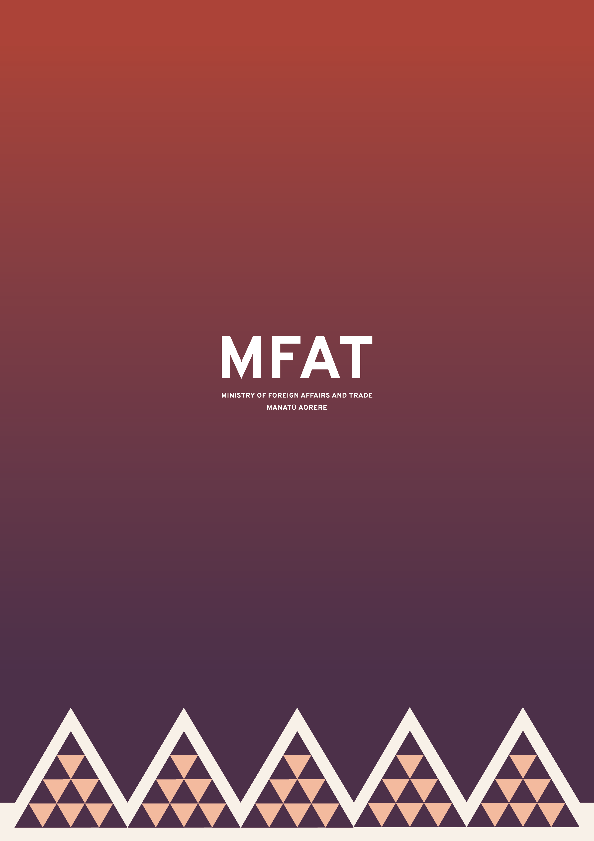

Incident details
Please give us some more information about the alleged incident providing as much detail as you can.
However, please only provide personal details of victims/survivors (such as name, address, age, gender and health) if you have their permission to do so.

Details of alleged incident:
(please provide details of the allegation including any specific vulnerabilities such as disability, sex worker, remote location etc)
When did it happen?  (provide date range if this was over a period of time or more than one incident) | dd/mm/yyyy
Is victim/survivor or alleged perpetrator a recipient or client of a MFAT programme/activity?
Is there a potential risk to other people?
Actions taken

What initial support has been/is being provided to the victim/survivor?
(eg medical support, counselling services, family support etc)
Has the victim/survivor been referred to support services?
(e.g. medical or counselling services)
If yes, please provide details

What investigation or reporting has or will be undertaken by the MFAT delivery partner?
How is the victim/survivor, or any other person at risk, being protected from further harm?

Reporting

If the alleged incident/allegation occurred outside New Zealand, are local authorities aware?
If yes, please provide details
How and when will the MFAT delivery partner report back on this incident?

Additional Information

(please provide any additional information that has not already been mentioned above and is relevant to the alleged incident).

