ASEAN-CER Integration Partnership Forum
Melbourne, 30 April 2019

Digital Trade and Inclusive Growth in ASEAN, Australia and New Zealand

Speakers

Ms Stephanie Honey – Chair of IPF 2019
Associate Director, New Zealand International Business Forum; Advisor, APEC Business Advisory Council; Co-Founder, Global Trade Insights

Stephanie is Associate Director of the New Zealand International Business Forum and serves as policy advisor to the New Zealand members of the APEC Business Advisory Council. Stephanie heads an independent trade policy consultancy working with government and business clients and is also co-founder of a business offering executive education in trade policy, Global Trade Insights. Stephanie’s areas of focus include regional economic integration especially in the Asia-Pacific, the WTO, agriculture and food trade, services trade and the digital economy, and SMEs and women in trade. Stephanie has travelled and worked widely in the Asia-Pacific, Europe and more broadly. Prior to becoming a consultant, Stephanie worked for many years as a trade negotiator for the New Zealand Ministry of Foreign Affairs and Trade, including serving as the New Zealand Agriculture Negotiator in the WTO Doha Round in Geneva, at the New Zealand Mission to the EU in Brussels working on trade issues, as the senior New Zealand official responsible for the bilateral relationship with Australia and in a variety of other roles.

Dr Joshua Meltzer
Senior Fellow, Brookings Institution

Dr. Meltzer is a senior fellow in the Global Economy and Development program at the Brookings Institution in Washington D.C. At Brookings. Meltzer is an expert on digital trade law and policy issues and leads Brookings Digital Economy and Trade Project. He also works on the legal and regulatory aspects of financing sustainable infrastructure projects to meet climate change and development needs.
Meltzer has testified on international trade and climate change issues before the U.S. Congress, the U.S. International Trade Commission and the European Parliament. He has been an expert witness in litigation on digital trade and privacy issues in the EU and a consultant to the World Bank on trade and privacy matters. He is also a member of Australia’s National Data Advisory Council.
Meltzer teaches digital trade law at Melbourne University Law School and a course on emerging technologies and the law at Monash University Law School. He has taught international trade law as an adjunct professor at Georgetown University Law School and Johns Hopkins School for Advanced International Studies, and has been a guest lecturer on digital trade at Columbia University Law School.
Prior to joining Brookings, Meltzer was posted as a diplomat at the Australian Embassy in Washington D.C. where he was responsible for trade, climate and energy issues and prior to that he was an international trade lawyer and trade negotiator in Australia’s Department of Foreign Affairs and Trade. He has also worked as an attorney at Sackville Wilks & Co in Melbourne, Australia.
Meltzer has appeared in print and news media, including the Economist, the New York Times, the Washington Post, CNN, Bloomberg, MSNBC, CBS, Fox, the Asahi Shimbun and China Daily. Meltzer holds an S.J.D. and LL.M. from the University of Michigan Law School in Ann Arbor and law and commerce degrees from Monash University in Melbourne, Australia.

Dr Fraser Thompson
Co-founder and Director of AlphaBeta

Dr. Fraser Thompson is Director and co-founder of AlphaBeta, an economic strategy firm based in Singapore and Australia, which aims to integrate economics and strategy to support business and government decision-making. Fraser previously led McKinsey Global Institute (MGI), the economic research arm of McKinsey, in Southeast Asia, and was also a consultant with McKinsey for 6 years, having worked across the United States, Europe, the Middle East, Africa, and Asia.

Prior to joining McKinsey, Fraser worked at The World Bank focused on East Asia and Northern Africa, and as an economics tutor at Oxford University. Fraser received a Doctorate and Masters in Economics from the University of Oxford, where he studied as a Rhodes Scholar. At the undergraduate level, Fraser studied at Melbourne University, Beijing Normal University, and Butler University. Fraser also served as the Inaugural President of the Australian Chamber of Commerce in ASEAN and remains a current board member. He is also a board member of AustCham Singapore, and a senior advisor to IMA Asia (which is a network of senior business leaders).

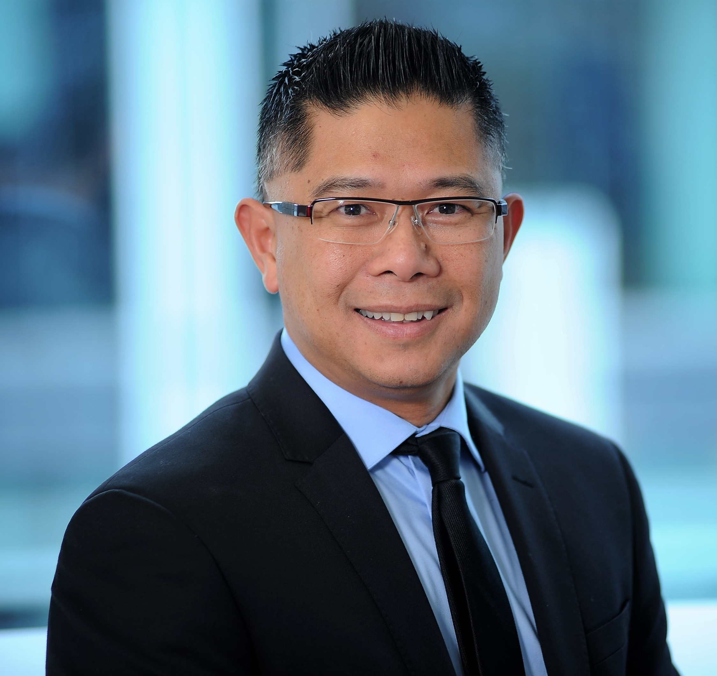 | Mr Mitchell Pham  Cofounder & director of Augen Software Group and Kiwi Connection Tech Hub; Chair NZTech and FinTechNZ  Mitchell is cofounder and director of Augen Software Group (ASG) and Kiwi Connection Tech Hub (KCTH). He is a cofounder of Smart Links Swiss (SLS) and Lina.network. He is also an advisor to many international technology companies.  In industry and government leadership, Mitchell is chairman of NZ Technology Industry Association (NZTech) and NZ Financial Technology Innovation Community (FinTechNZ). He is cofounder of the NZ Health IT Cluster (NZHIT) and InsurTechNZ and Global InsurTech Alliance (GITA). He is also advisory board member of the Asia New Zealand Foundation, former advisor at the Ministry of Business, Innovation & Employment (MBIE), and cofounder & chairman of ASEAN-NZ Business Alliance (ABA).  In business community, Mitchell is a New Zealand Trade & Enterprise (NZTE) Beachheads Advisor for South East Asia. He is chairman of advisory board of NZ Asia Institute (NZAI) and entrepreneur-in-residence at the University of Auckland Business School (UABS). He is also a member of Ethnic People in Commerce (EPICNZ), advisory board member of NZ Asian Leaders (NZAL) forum, and member of NZ Superdiversity Council.  Internationally, Mitchell is recognised as a World Class New Zealander by KEA Global, an Asia 21 Fellow by the Asia Society, and a Young Global Leader by the World Economic Forum.  Some highlights from Mitchell's work:  - Mitchell has advised, assisted, consulted, developed and delivered for many traditional service businesses to successfully transform into modern digital/tech companies, some also progressed to being acquired by global giants;  - Mitchell was first to lead senior executives in financial services businesses and government regulators and policy makers to come together to engage across the entire innovation ecosystem for: FinTechNZ (2017), InsurTechNZ and Global InsurTech Alliance (GITA) (2018), and WealthTechNZ (including InvestTech) (2019). He also led FinTechNZ to join the ASEAN Fintech Alliance Network in November 2017;  - One of Mitchell's Blockchain businesses' Cryptocurrency token is about to become an official currency in one of the ASEAN economies. They are also working with investment groups, industry partners and government agencies to pioneer and launch the first fully-licensed exchange and ecosystem for STO’s (Security Token Offering’s) in Asia;  - Mitchell is first to lead as Chair of the NZ technology industry to transform from a stand-alone sector to become an integral part of and key enabler for all other industries across the economy. The transformation template that he developed for FinTechNZ has been applied to EdTech, AgriTech, FoodTech, CreativeTech, Blockchain, AI, IoT, AR/VR and other emerging industry groups who are leading new innovation and digital transformation across their respective sectors;  - Mitchell was one of the first to fully expand and operationalise a NZ tech services company into ASEAN region. He led the team at Augen to develop an innovative business & organisational & operational model that delivers 100% project success where traditional engagements between NZ and Asia have been fraught with high risks and many failures - both the business model and the resulting works have won international awards;  - Mitchell led the first private business to work collaboratively in partnership with government agencies to establish a commercial facility to help tech companies accelerate their presence and engagement in South East Asia - this platform is now attracting interest from NZ tech companies and from Australia and the US.
Louise McGrath
National Manager – Business and International Advisory Services,
Australian Industry Group

Louise has a broad range of experiences in international relations and is responsible for international engagement at the Australian Industry Group.

Prior to joining The Australian Industry Group in 2000, Louise worked in wholesale foreign exchange and insurance. Since joining Ai Group she has managed a number of trade related projects including trade missions, both incoming and outgoing, business matching and the development and delivery of export related training programs. She has had extensive experience in providing advice to manufacturing companies on export related planning and international marketing, government support programs and other trade related issues. She represents Australian industry in several multilateral forums, such as the Global Business Coalition and the B20 Taskforce on Digital Trade and various Free Trade Agreement Industry working groups, including the East Asia Business Council RCEP working group. She advocates for the interests of Ai Group members during Free Trade Negotiations and translates those agreements to support the strategic aims of members.

Louise has studied a Bachelor of Arts (Arabic Language and Culture) at Deakin University and an Advanced Diploma in International Trade at RMIT. She has also studied Arabic at universities in Jordan and Egypt.

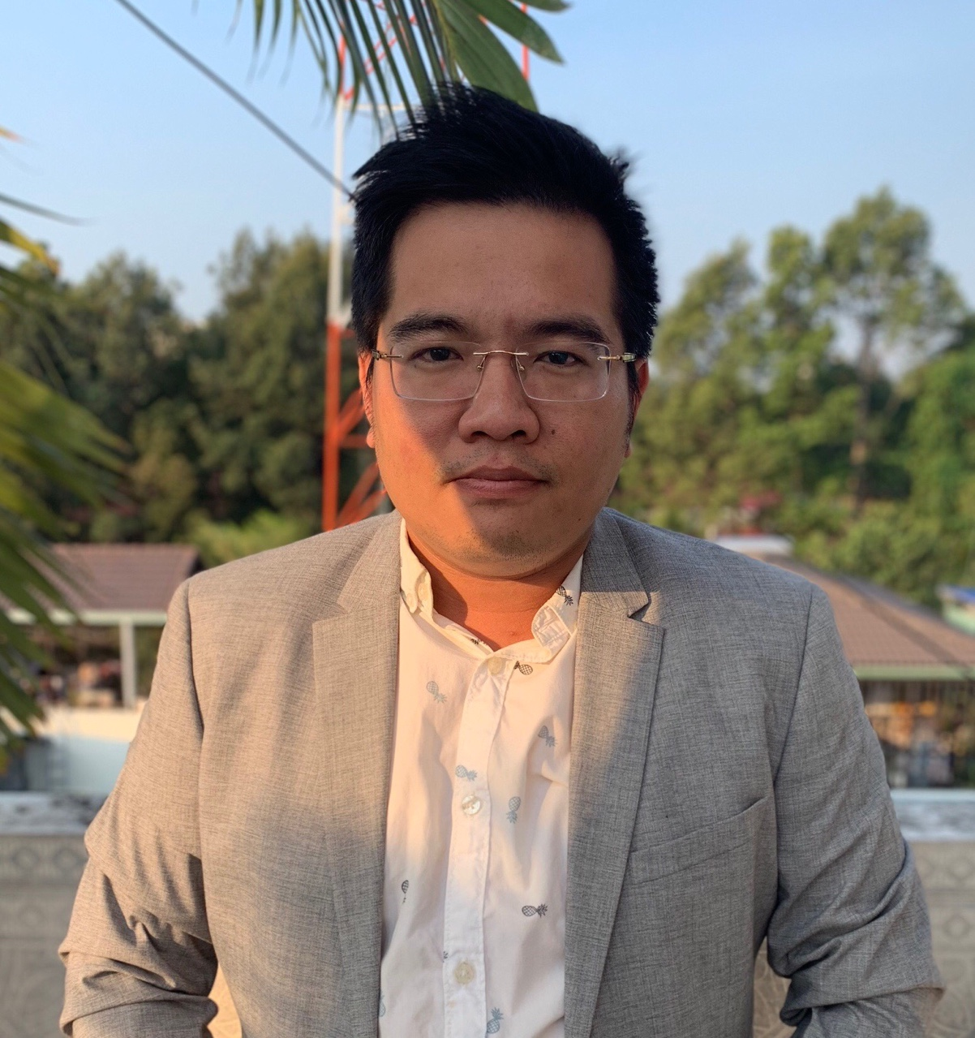 | Willy (Nguyen) Pham  Founder and CEO of Acquire  Willy (Nguyen) Pham is the founder and CEO of Acquire – a Digital Marketing Business of the Square Group which provide Performance Marketing and apply new solutions for businesses in the Vietnam market and ASEAN region. Willy is also Chief Marketing Officer of T-Rex – a Blockchain ecosystem with a cryptocurrency exchange, a knowledge academy and a startup incubator and investment venture.  Before Acquire, Willy was in charge of the Traffic team for the ASEAN region at VNG (formerly VinaGames) Corporation – one of the largest tech companies in South-East Asia, with the largest market share in gaming in Vietnam and top in the ASEAN region. He and his team worked with Facebook, Google, Ad Network, and others to grow VNG user base and increase revenue across the region. Willy led VNG’s regional gaming market research and strategy development as well as execution.  Willy’s broad industry knowledge, experience, relationships and connections come from working with industry leaders in Gaming, Real Estate, ICT, Food & Beverages, Education, Healthcare, including brands such as MSD, VNG (VinaGames), IPPG (Domino Pizza), CGV, Hado Group, DXMN, DKR, NHG, Jotun, and many others.
Matthew Prouse
Head of Industry, Xero

As Head of Industry at Xero, Matthew helps connect government agencies, policymakers, accountants, bookkeepers, business owners and software developers to the digital economy. Matthew regularly represents the software, accounting and small business industries in Australia and New Zealand, connecting them with parliament, tax authorities and other key government agencies. Matthew is an elected director of the Australian Business Software Industry Association and Xero's representative on a number of government and industry working groups. Prior to joining Xero six years ago, Matthew spent eight years as an accountant in public practice in Western Australia.

Alana Hudson
Head of Services and Investment, Trade Negotiations Division, New Zealand Ministry of Foreign Affairs and Trade

Alana is a New Zealand diplomat and experienced trade negotiator. In her current role she leads a team engaged in New Zealand’s trade negotiations across the areas of services, investment and e-commerce/digital trade. Throughout an 18 year career she has led and supported bilateral and multilateral negotiations across areas including goods trade, intellectual property, agriculture policy, and customs procedures. She was New Zealand’s negotiator for the WTO’s Trade Facilitation Agreement and the Information Technology Agreement expansion process between 2011 and 2015. She has served overseas in both Geneva and Brussels, and was Lead Adviser for Latin America from 2015-2018, leading New Zealand’s engagement with the Pacific Alliance.

Kah Mei Chan
Deputy Director, International Trade Cluster, Singapore Ministry of Trade and Industry

Chan Kah Mei is a Deputy Director at the Trade Division of the Ministry of Trade and Industry in Singapore. She heads the teams on the Digital Economy and Services.

Prior to this, Kah Mei held portfolios in the WTO, APEC, South Asia and Middle East divisions and was posted to the Singapore High Commission in New Delhi as Counsellor (Economics) from May 2011 to 2014.

Kah Mei started her career as a broadcast journalist at Mediacorp Radio in Singapore. She later spent time at the Institute of South East Asian Studies (ISEAS) as a research associate.

Kah Mei graduated with a Bachelor of Communications Studies (Hons), Second Class (Upper) from the Nanyang Technological University, Singapore in 2000. She obtained a Masters of Science (Politics), First Class, at the School of Oriental and African Studies, University of London under the Dato Tan Cheng Lock Scholarship from the Institute of South East Asian Studies in 2004.

Datuk Yasmin Mahmood
Managing Director, FutureReady Consulting Sdn Bhd

Datuk Yasmin Mahmood, the Managing Director of FutureReady Consulting Sdn Bhd, is a much sought-after global thought leader in Digital Economy Transformation, Consultancy and Implementation throughout the ASEAN region. Throughout her illustrious career spanning three decades, Yasmin had served both the Public and Private Sectors, which places her in a credible position on overseeing Public-Private Partnerships to realise ‘Win-Win’ situations and sustainable growth.
She started her career as an analyst programmer with a local bank after graduating with a double-major in Computer Science and Mathematics. She subsequently worked her way up to become General Manager of Hewlett Packard Malaysia’s Commercial Channels Organisation. She then took on the dual-role of General Manager and Regional Corporate Director of Dell Malaysia.
Yasmin moved on to become Microsoft Malaysia’s Managing Director in 2006 and became known for her “Malaysianising Microsoft” mantra and for aligning the strengths of what was then the world’s most powerful software company with Malaysia’s national and development agenda.
In September 2014, she took on the much-coveted post of CEO of Malaysia Digital Economy Corporation (MDEC) Sdn Bhd; to make a difference and to utilise her expertise and experience for the betterment of the nation. This was achieved on the back of Yasmin spearheading the MDEC team to continuously bring in FDIs into Malaysia, while spearheading strategic nation-building initiatives such as the Digital Free Trade Zone (DFTZ), and nurturing the local technology ecosystem including start-ups and local companies to be world-class and citizen-centric programmes to drive digital inclusivity.
Datuk Yasmin has also represented Malaysia and ASEAN at major international events which include the World Economic Forum (WEF), International Telecommunication Union (ITU), the World Islamic Economic Forum (WIEF); as well as having been interviewed by international media such as Forbes, the Economist, CNBC and Bloomberg for her thoughts and insights.
Datuk Yasmin is also an active advocate of women empowerment in the workplace, and a Founding Patron of Gorgeous Geeks, an NGO advocating Women Empowerment with ICT. She has also lent her support for the Asian Chapter of the Lean-in Career Programme, an initiative that empowers, enables, and educates women to accelerate their professional careers.

In 2018, Datuk Yasmin was recognised as one of the the world’s 100 most influential people in Digital Government by Apolitical, an independent UK-based global network for government which focuses on helping public servants find solutions to issues.

Dr Peter Lovelock
Director and co-Founder of the Technology Research Project Corporate

Peter Lovelock is Director and co-Founder of the Technology Research Project Corporate (TRPC), an IT and telecommunication-based think-tank with offices in Singapore, China and Australia. He brings more than 25 years experience in telecoms, technology and media to these undertakings, including regulatory assessments for governments and multilateral groups, implementation and execution projects, and due diligence and market entry strategic guidance projects throughout Asia.

TRPC provides in-depth research and consulting services to leading technology companies; to institutions such as APEC and ASEAN, the World Bank, ITU, ADB, and the UN; as well as for regulators regionally and globally.
Dr Lovelock has been a senior strategic advisor to a number of large technology companies, and is currently an advisor to PECC and APEC on the internet and digital economy roadmap. He sits on the board of the International Institute of Communications (IIC) and the Asia Cloud Computing Association (ACCA), among others.

